Special Discounts For Player Card Holders  Discount good for entire year for each visit, for Player Card Holder only  10% off your meal at 10% off your meal at  Together, we are Building Game Changers You MUST identify yourself as a Player Card holder PRIOR to asking for an available tee time. If you do not identify yourself as a Player Card holder prior to making the tee time, the course DOES NOT have to honor your tee time. |  | The First Tee Nine Core Values:  Honesty  Integrity  Sportsmanship  Courtesy  Confidence  Respect  Responsibility  Judgment  Perseverance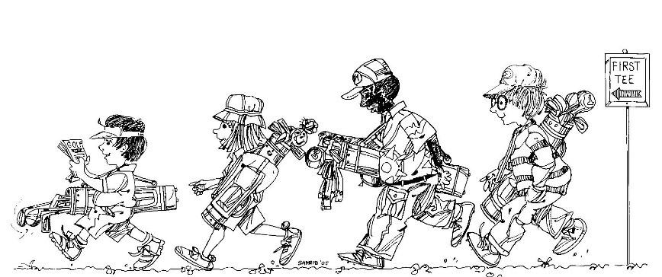  The First Tee Code of Conduct:  Respect for Myself  Respect for Others  Respect for My Surroundings |  | #: 00001  2021 PLAYER CARD  _______________________  Player’s Printed Name  _______________________  Player’s Signature  First Tee – Coastal Carolinas  PO Box 1820, Shallotte, NC 28459  910-754-5288 Office  www.FirstTeeCoastalCarolinas.org

Participating Golf Courses  Brick Landing 910-754-2745 24 Hours in Advance $35 AM / $30 PM Compass Pointe 910-777-7766 48 Hours in Advance $30 PM Only  Cape Fear National 910-383-3283 48 Hours in Advance $75 Year Round Crow Creek 910-287-3081 24 Hours in Advance $44 AM / $39 PM  Carolina Colours 252-772-7022 $25 after 10 AM Tue-Fri and after 11 AM Sat & Sun Emerald Golf Club 252-633-4440 $30 after 11 AM  Carolina National 910-755-5200 24 Hours in Advance $44 AM / $39 PM Farmstead 910-575-7999 24 Hours in Advance $44 AM / $39 PM  Carolina Shores 910-579-2181 $28 Year Round Ironclad Golf & Beer Garden $20 for 9 Holes 910-777-7725  Cinghiale Creek Par 3 910-754-5288 M-F 9 AM-4 PM $10 Lockwood Folly 910-842-5666 24 Hours in Advance $35 Year Round |  | Magnolia Greens 910-383-0999 48 Hours in Advance $30 PM Only Ocean Ridge - Tiger’s Eye 910-287-7227 24 Hours in Advance $40 PM Only  Meadowlands 910-287-7529 24 Hours in Advance $35 AM / $30 PM Olde Fort Golf Club 910-371-9940 48 Hours in Advance Call for Special Player Card Rates  Oak Island Golf Club 910-278-5275 48 Hours in Advance $30 Year Round Olde Point Golf Club 910-270-2403 48 Hours in Advance $30 After 10 AM  Ocean Ridge-Leopard’s Chase 910-287-1717 24 Hours in Advance $40 PM Only Oyster Bay 910-579-3528 48 Hours in Advance $30 PM Only  Ocean Ridge - Lion’s Paw 910-287-1703 24 Hours in Advance $35 Year Round The Pearl 910-579-8132 24 Hours in Advance $35 AM / $30 PM  Ocean Ridge - Panther’s Run 910-287-1703 24 Hours in Advance $35 Year Round River Bend 252-638-2819 $30 after 11 AM |  | River’s Edge Golf Club 910-755-3434 24 Hours in Advance $44 AM / $39 PM Thistle Golf Club 910-444-2500 48 Hours in Advance $44 Year Round  Sandpiper Bay 910-579-9120 24 Hours in Advance $35 Year Round Castle Bay 910-270-1978 $33 Mon-Thurs No Holidays  Sea Trail - Maples 910-287-1125 48 Hours in Advance $30 Year Round Wilmington Municipal 910-791-0558 $29.25 Year Round  Sea Trail - Jones 910-287-1122 48 Hours in Advance $30 Year Round Thank You For Your Support!  Sea Trail - Byrd  910-287-1122  48 Hours in Advance  $30 Year Round  The Lakes  910-845-2625  Call for Special Player Card Rates

